Showcase Review: Provence Moulage Bugatti-Powered Boat
by Wayne E. Moyer
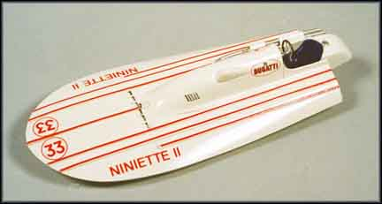
OK, I know-- what's a boat doing on the Model Car Hub? Well, look closely-- see that big Bugatti emblem? And there's still another Bugatti connection here that I haven't completely unraveled at this point. For those who haven't been paying attention, Provence Moulage seems to have embarked upon a series of models of racing hydroplanes with automobile engines; first a Ferrari-powered boat, then one with an Alfa engine, another with an Isotta-Fraschetti engine, and now a Bugatti-powered record setter.
According to "Classic Speedboats, 1916-1939" by Gerald Guetat, Niniette II set a new speed record of 63.29 mph on November 12, 1931 for boats with engines of up to six liters, although it had "only" 4.7 liters of Bugatti straight-eight engine. Niniette II was owned by Italian Prince Maurizio Ruspoli, although it's not clear whether or not he was behind the wheel during the record run. Apparently Ruspoli continued to build Bugatti-powered hydroplanes, though no further records were set until Niniette VI, using a 4.9 liter Type 50B Bugatti engine, pushed the record for six-liter boats to 83.15 mph on November 27, 1937 with Maurice Vasseur driving. Niniette VI is the only 100% Bugatti boat (hull and engine) boat known to have been constructed at the shipyard Ettore purchased in 1937. And in case you're still wondering what the other Bugatti connection was, Bugatti historian points out that "Niniette" was the Bugatti family nickname for Lydia Bugatti-- so why is an Italian Prince naming boats-- even fast boats-- after her?
The Provence Moulage kit of Niniette II has a simple, but very nicely cast solid one-piece resin hull with a separate cockpit floor with the seat cast on the upper side and the rudder and driveshaft support on the lower surface. A single big exhaust pipe, prop, black plastic steering wheel and a straight pin for the prop shaft completes the kit. A simple two-piece stand and decals are included, but the instructions, which consist of only two photos of the upper surface, aren't a whole lot of use except to see where the decals go. My kit had only a couple of small mold lines and a little flash on the lower surface of the hull, along with some feed tags inside the cockpit and on the back of the hull. Initial cleanup took only a few minutes, but the first primer coat showed a couple of "pits" on the sides that required a dab of putty. There were no real problems, though, and I doubt if the total time required to get the hull ready to paint was as much as 30 minutes.
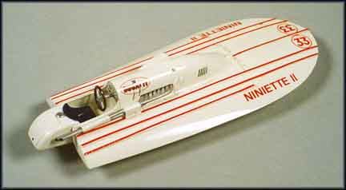
The only photos I found show that Niniette II was a very light color and although P.M. says to paint her "Beige" I really think she was probably painted in the typical off-white color of that period. I used Ford Wimbolden White, which has a slight cream tint, and added just enough brown to change the tint from yellow to "beige". Although P.M's "instruction photos", which are of a built-up model, don't show this, a photo in Classic Speedboats very clearly shows that the ribs on top of the hull are painted a darker color that seems to match the red in the big Bugatti emblem. Hand-painting the top of the ribs was beyond my capability, and my decal box didn't have any red stripes of the correct width, but I did have some red Chart-Pak tape. As it turns out, the tape had enough "stretch" to match the gentle curve in the ribs very well and worked perfectly. Once the tape and all the decals were in place, I sprayed on several coats of clear gloss lacquer to make sure they stayed there. Painting the seat semi-gloss blue, the prop "bronze", and the exhaust pipe and rudder "steel" took only a few minutes; "final assembly" took even fewer.
I have only the one photo of Niniette II and another of her very similar predecessor Niniette, but my finished model matches them very well. I'm not sure that the completely flat-bottomed hull is correct, but I'm not sure it's wrong, either. I do know that the rules of the period did not allow a "step" in the bottom of the hull and that the idea of planing on small sponsons hadn't been developed yet. Overall length scales out to 20.5 feet with a beam of 8.3 feet; I don't have dimensions but they appear to be reasonable if the driver was a "normal-size" human. All, in all, Provence Moulage's kit of Niniette II was very easy to build and produces a very good-looking model. And just wait until you see her on a trailer towed by a Type 46 Bugatti! The P. M kit is available from Grand Prix Models, 3 Noke Lane Business Centre, St. Albans, Herts, AL2 3NY. England (FAX 0727 84 5858, website www.grandprixmodels.co.uk) for about $47.00 plus shipping.
